**Creating Azure SQL DataBase and firewall rules**.

Creating Resource Group.

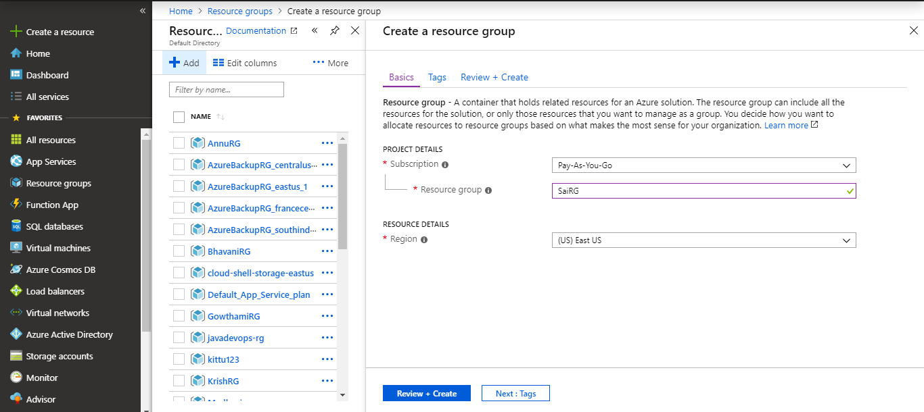

Created Azure SQL DataBase.

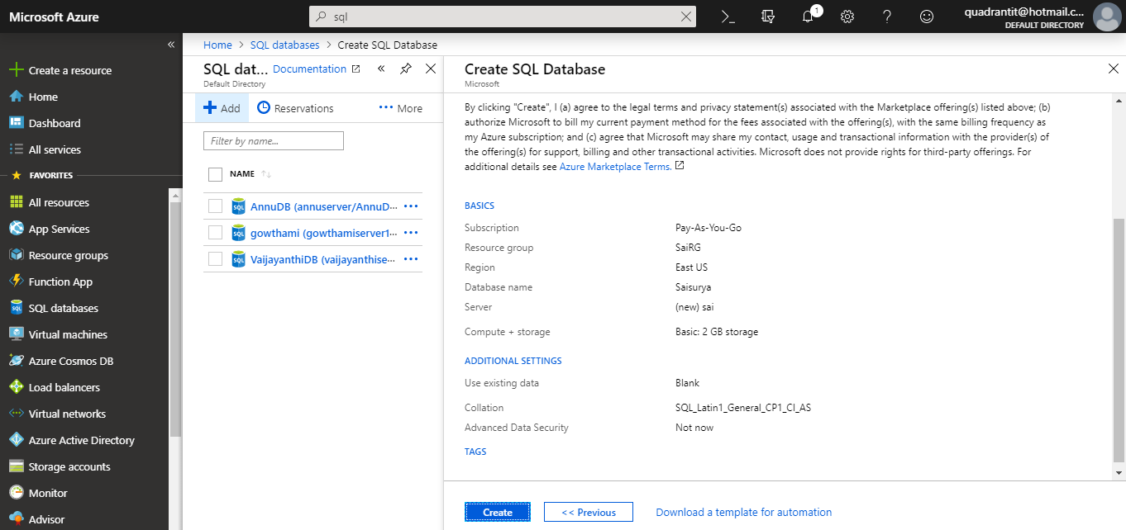



Created firewall conncetion.

